|  |  |
| --- | --- |
|  | *Shahid Smarak College* |

*Kathmandu, kirtipur – 10*

*Lab Report of Data Structure and Algorithm*

Submitted by: -

Amir Maharjan

BCA 3rd Semester

Submitted to: -

Department of BCA.

Introduction

Data structure is a way of organizing all data items and establishing relationship among those data items.

Data structures are the building blocks of a program. It mainly specifies the following four things.

* Organization of the data
* Accessing methods
* Degree of associativity
* Processing alternatives for information

To develop a program of an algorithm, we should select an appropriate data structure for that algorithm. Therefore, algorithm and its associated data structures form a program.

Algorithm + Data Structure = Program.

Lab 4

Implementation Of AVL trees

Program

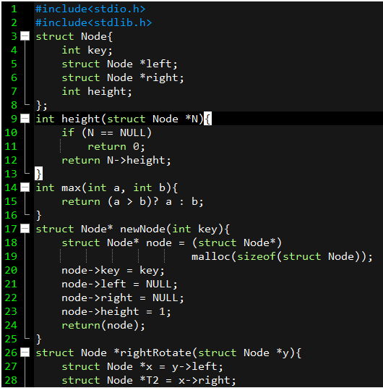

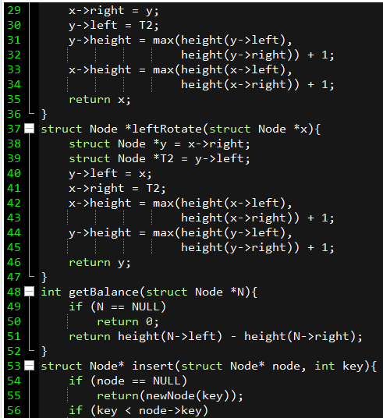

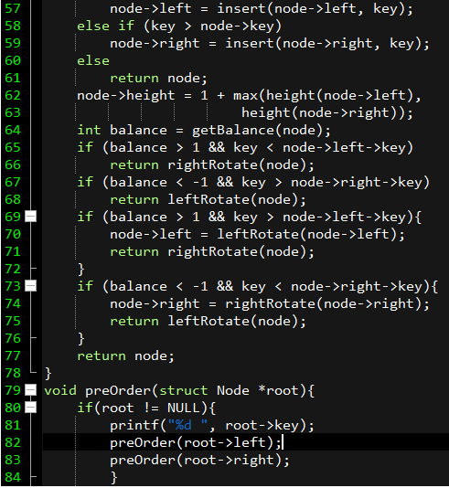

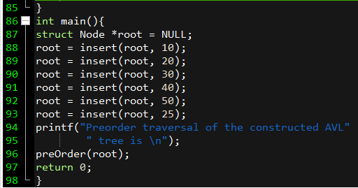

Output

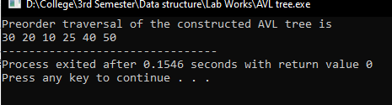

Lab 5

Implementation of Merge sort

Program

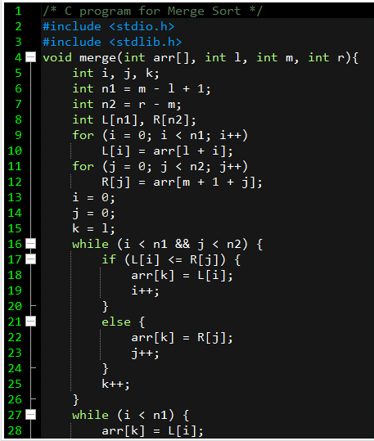

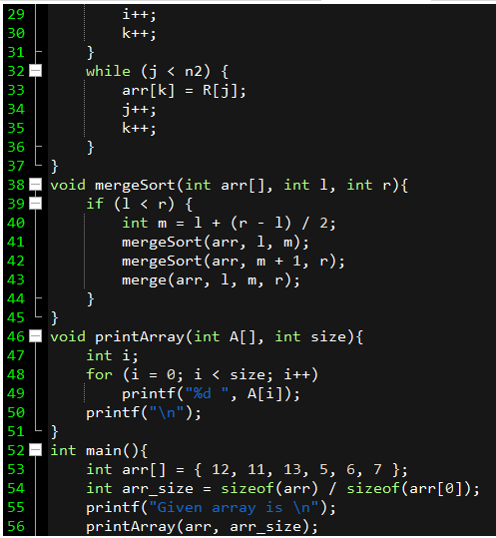

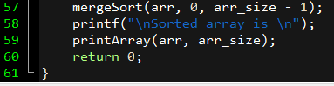

Output

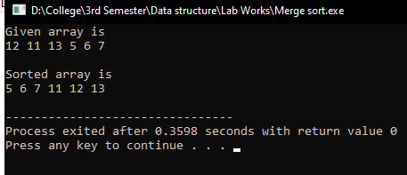

Lab 6

Implementation of Heap

Program

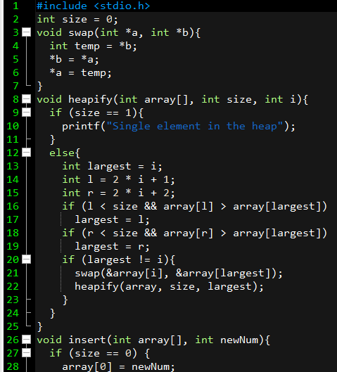

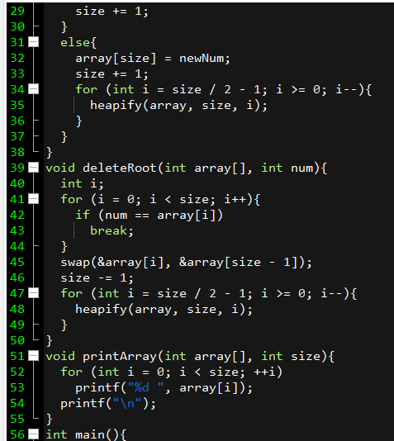

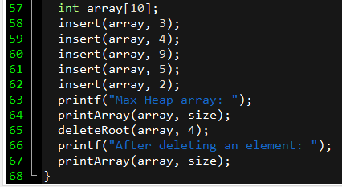

Output

